Project landing page URL -http://10.60.36.1/~srasool/
Disclaimer message is on the imprint page.
Corporate Design Description
- Logo
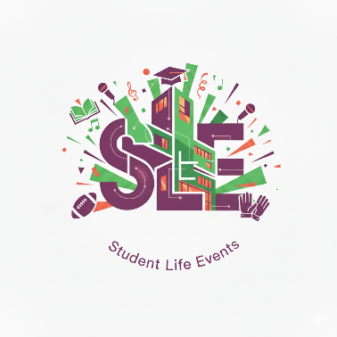
S – Stefan
L – Luca
E - Elyas
- Color palette
Header Background (Purple): #8E44AD
Main "Welcome" Background (Muted Teal): #7098a1
Default Page Background (Green): #478341
Default Text (Dark Charcoal): #0b0f13
Primary Accent (Purple): #8E44AD
Link Color (Blue): #3498DB
Active Navigation (Teal): #1ABC9C
3) Typography
Font Family: 'Montserrat' is used for all headings (h1, h2, h3) and the navigation menu links, creating a unified and stylish look. The default font-weight for these is 800, making them bold and prominent.
Readability: Paragraph text has a generous line-height of 1.8em, providing ample space between lines for comfortable long-form reading. The base font size is 16px.
Main Container: A central container with a width of 1200px (.container) is used to hold the content. It is centered on the page using margin: 0 auto;, ensuring a consistent look on larger screens.
Section-Based Design: The layout is divided into horizontal sections (#wrapper1, #wrapper2) with distinct background colors to logically separate content blocks.
Column Layout: A four-column floated layout is used for content sections like the portfolio, with each column taking up 22.5% of the container width.

https://elementor.com/blog/colors-in-css - for the color codes

